Lab 5

1

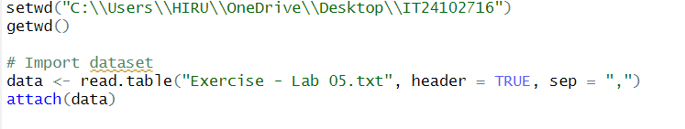

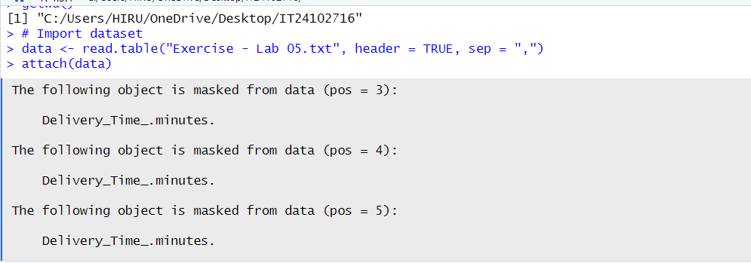

2

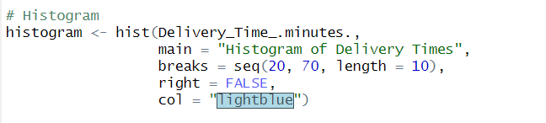

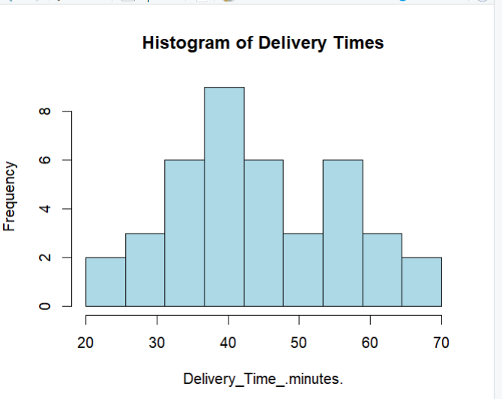

3

The histogram of delivery times is slightly right-skewed. Most deliveries fall between 30 and 45 minutes, while a few longer times stretch the distribution to the right.

4

